**Class:** Final Year (Computer Science and Engineering)

**Year:** 2022-23 **Semester:** 1

**Course:** High Performance Computing Lab

**Practical No. 5**

**Exam Seat No: 2019BTECS00037**

**Title of practical: Study of MPI**

**Problem Statement 1: : Implement a simple hello world program by setting number of processes equal to 10.**

*#include "mpi.h"*

*#include <stdio.h>*

*int main( int argc, char *argv[] )*

*{*

*int rank, size;*

*MPI_Init( &argc, &argv );*

*MPI_Comm_rank( MPI_COMM_WORLD, &rank );*

*MPI_Comm_size( MPI_COMM_WORLD, &size );*

*printf( "Hello World from process %d of %d\n", rank, size );*

*MPI_Finalize();*

*return 0;*

*}*

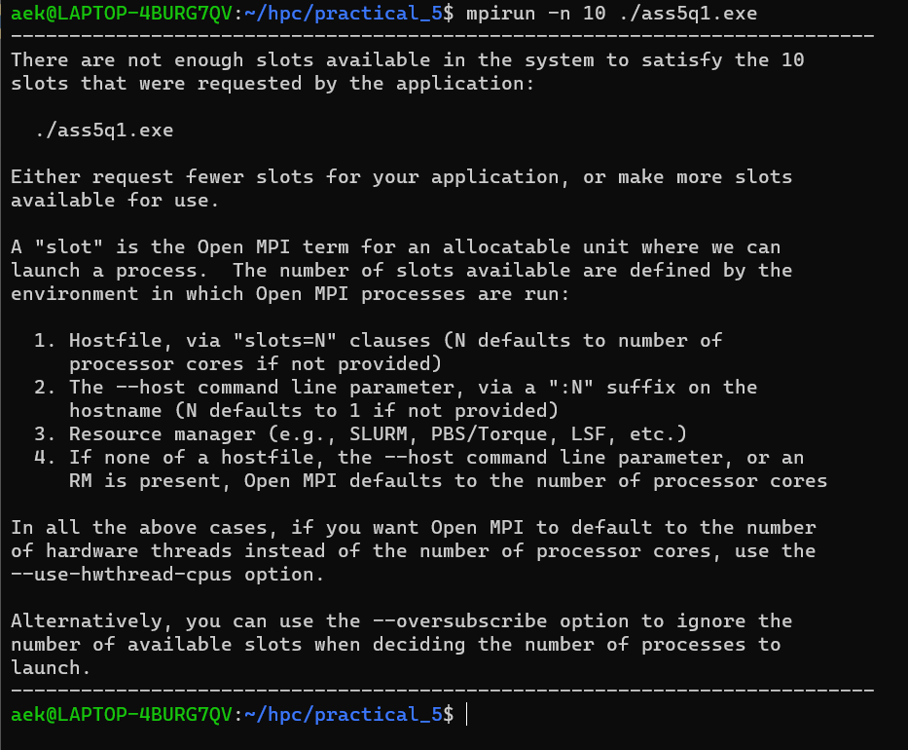

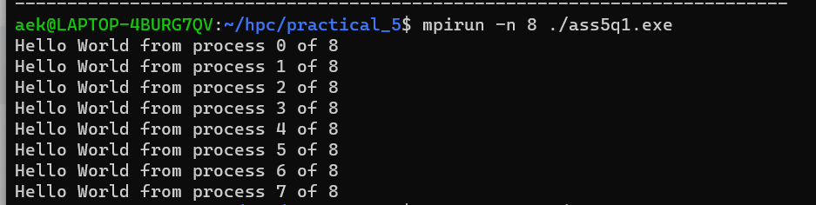

**Problem Statement 2: Implement a program to display rank and communicator group of five processes.**

*#include <mpi.h>*

*#include <stdio.h>*

*int main(int argc, char **argv)*

*{*

*MPI_Init(NULL, NULL);*

*int world_size;*

*MPI_Comm_size(MPI_COMM_WORLD, &world_size);*

*int world_rank;*

*MPI_Comm_rank(MPI_COMM_WORLD, &world_rank);*

*int color = world_rank / 2;*

*MPI_Comm row_comm;*

*MPI_Comm_split(MPI_COMM_WORLD, color, world_rank, &row_comm);*

*int row_rank, row_size;*

*MPI_Comm_rank(row_comm, &row_rank);*

*MPI_Comm_size(row_comm, &row_size);*

*printf("World Rank/Size : %d/%d \t Row Rank/Size: %d/%d\n", world_rank, world_size, row_rank, row_size);*

*MPI_Finalize();*

*}*

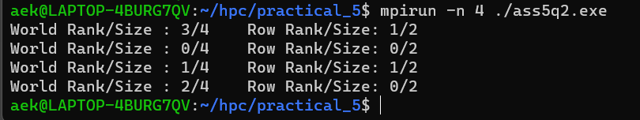

**Github Link:**

[**https://github.com/OnkarGavali/HPC_Lab/tree/main/Practical_No5**](https://github.com/OnkarGavali/HPC_Lab/tree/main/Practical_No5)